GSRS Installation Manual

Install Pre-requisites:

1. Unzip “GSRS Install.zip” to c:\ drive
2. Open folder “C:\GSRS Automation 1.0 Setup\
3. Install SQLExpress 2019 by clicking on “SQL Express 2019.exe”
   1. Select Basic Option
   2. Continue with Install process till end
4. Install Microsoft SQL Server Management Studio by clicking on “SQL Mgmt Studio.exe”
5. Open Microsoft SQL Server Management Studio using the shortcut on the desktop or on the start menu; “Microsoft SQL Server Management Studio 18”
   1. Login to the DB server using “Windows Authentication.

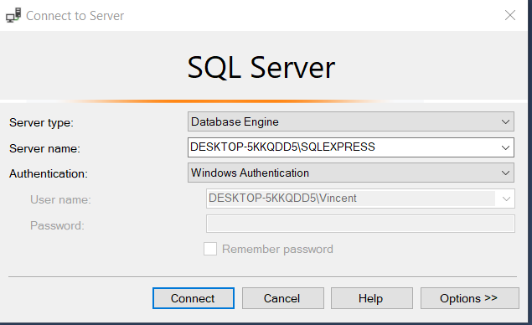

* 1. After the successful login Create an admin user by executing below query

file Create_DBUser.sql

File 🡪 Open 🡪 File C:\GSRS Automation 1.0 Setup\Create_DBUser.sql

Select all using CTRL+A and Click on “Execute” button

* 1. Right Click on SQL Express Icon in the left panel, to enable SQL Server Authentication mode
     1. Properties 🡪 Select Security Tab and Select “SQL Server …” option

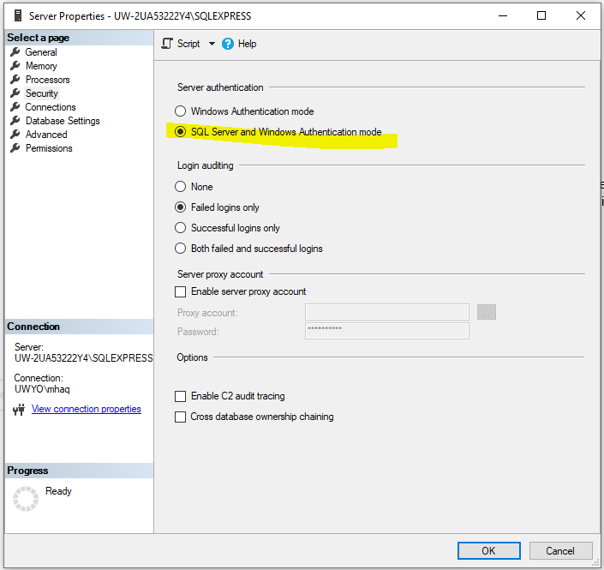

Click OK, and Restart SQL Server Express by following below steps

RUN command 🡪 services.msc 🡪 Scroll to “SQL Server Express” server and Right click 🡪 Restart

* 1. Close Microsoft SQL Server Management Studio, and Login back using the Admin User, with SQL Server Authentication

Login – admin

Password - password

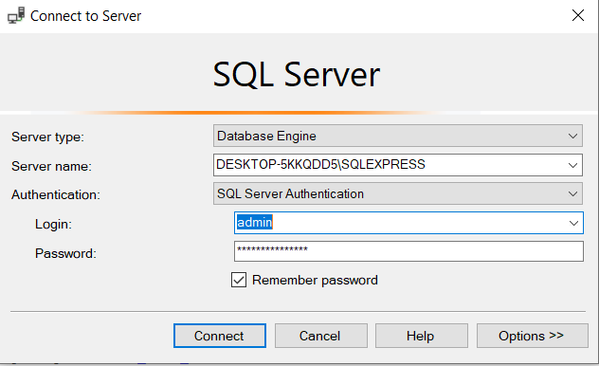

* 1. Create GSRS database by executing below query

file Create_GSRS_Database.sql

File 🡪 Open 🡪 File C:\GSRS Automation 1.0 Setup\Create_GSRS_Database.sql

Select all using CTRL+A and Click on “Execute” button

* 1. Run GSRS DB Scripts to create necessary tables and stored procedures by executing below file Create_GSRS_Tables_SP_Scripts.sql

File 🡪 Open 🡪 File C:\GSRS Automation 1.0 Setup\ Create_GSRS_Tables_SP_Scripts.sql

Select all using CTRL+A and Click on “Execute” button

1. Install the .Net Framework 4.7.2 by clicking on C:\GSRS Automation 1.0 Setup\ .Net Framework 4.7.2.exe, follow the instructions.

Install GSRS Automation:

1. Install GSRS Automation software by clicking on C:\GSRS Automation 1.0 Setup\setup.exe
   1. Click Next

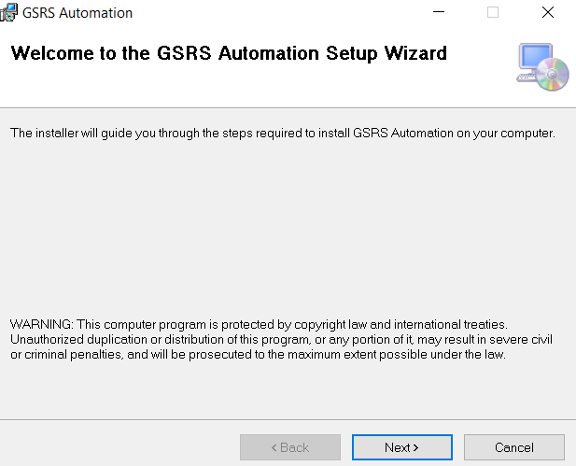

* 1. Choose “Everyone” and leave the default path "C:\Program Files (x86)\", Click Next

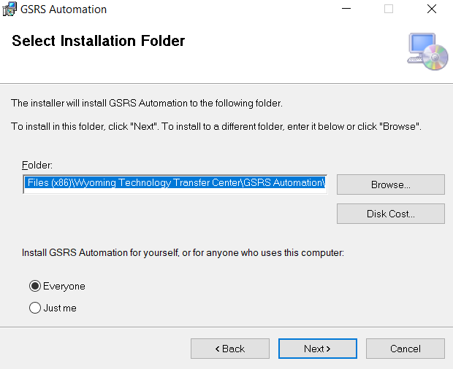

* 1. Click Yes or Next on next screens and finally close the application.

1. Create GSRS Automation software shortcut in start menu.
   1. Right click on C:\GSRS Automation 1.0 Setup\create_shortcut.bat and “Run as Adminstrator”

